Generative Adversarial Nets

1 Introduction

In the proposed *adversarial nets* framework, the generative model is pitted against an adversary: a discriminative model that learns to determine whether a sample is from the model distribution or the data distribution. The generative model can be thought of as analogous to a team of counterfeiters, trying to produce fake currency and use it without detection, while the discriminative model is analogous to the police, trying to detect the counterfeit currency. Competition in this game drives both teams to improve their methods until the counterfeits are indistiguishable from the genuine articles.

2 Related work

3 Adversarial nets

The adversarial modeling framework is most straightforward to apply when the models are both multilayer perceptrons. To learn the generator’s distribution pg over data x, we define a prior on input noise variables pz(z), then represent a mapping to data space as G(z;θg), where G is a differentiable function represented by a multilayer perceptron with parameters θg . We also define a second multilayer perceptron D(x; θd) that outputs a single scalar. D(x) represents the probability that x came from the data rather than pg. We train D to maximize the probability of assigning the correct label to both training examples and samples from G. We simultaneously train G to minimize log(1 − D(G(z))):

In other words, D and G play the following two-player minimax game with value function V (G, D):



4 Theoretical Results

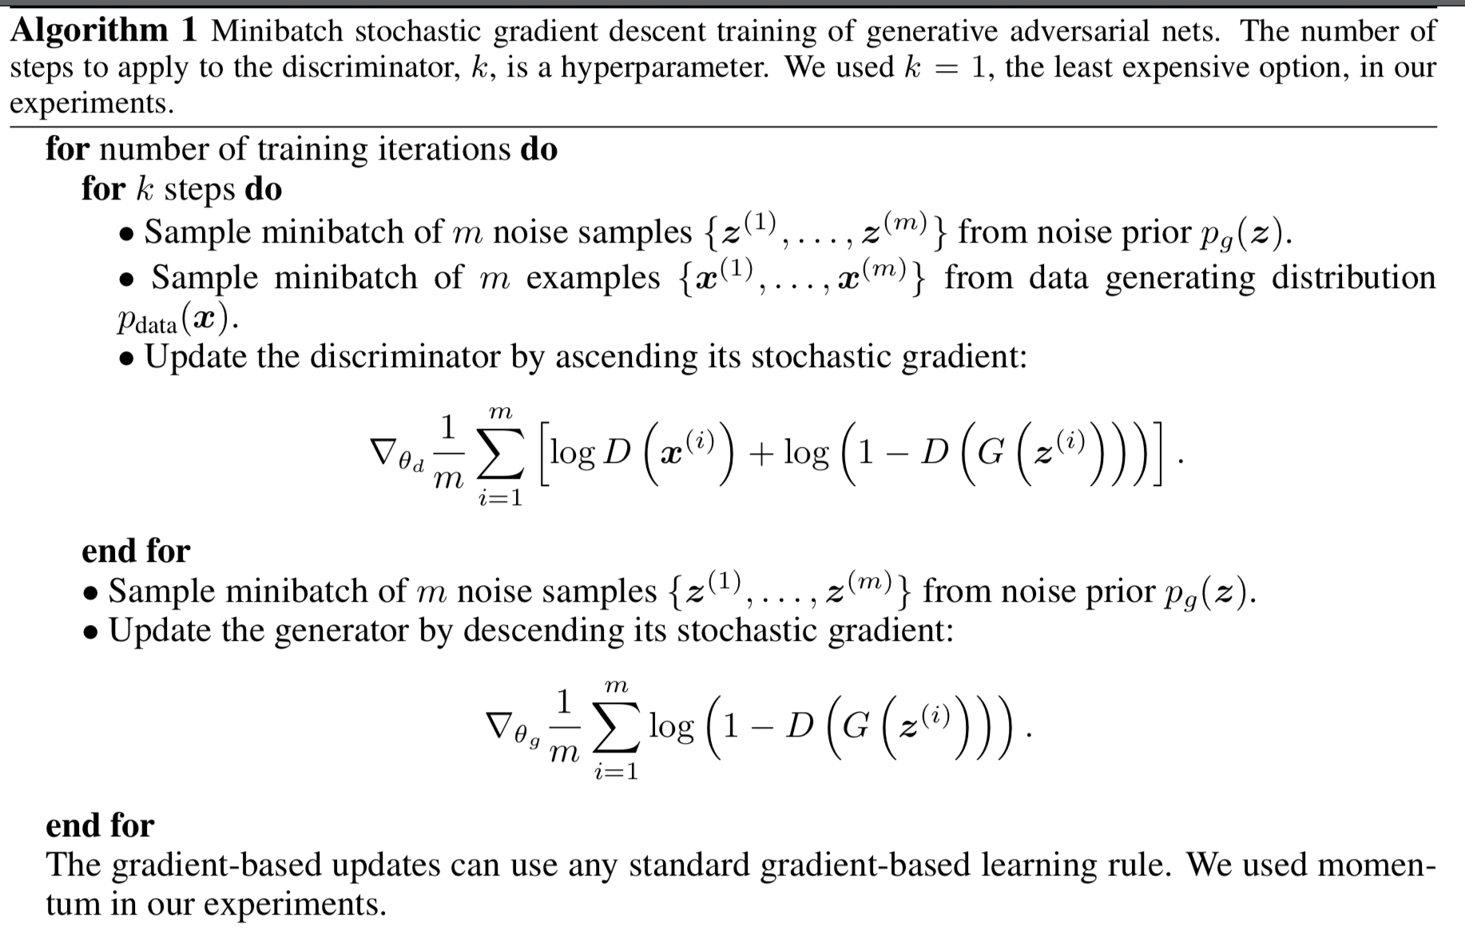

4.1 Global Optimality of pg = pdata

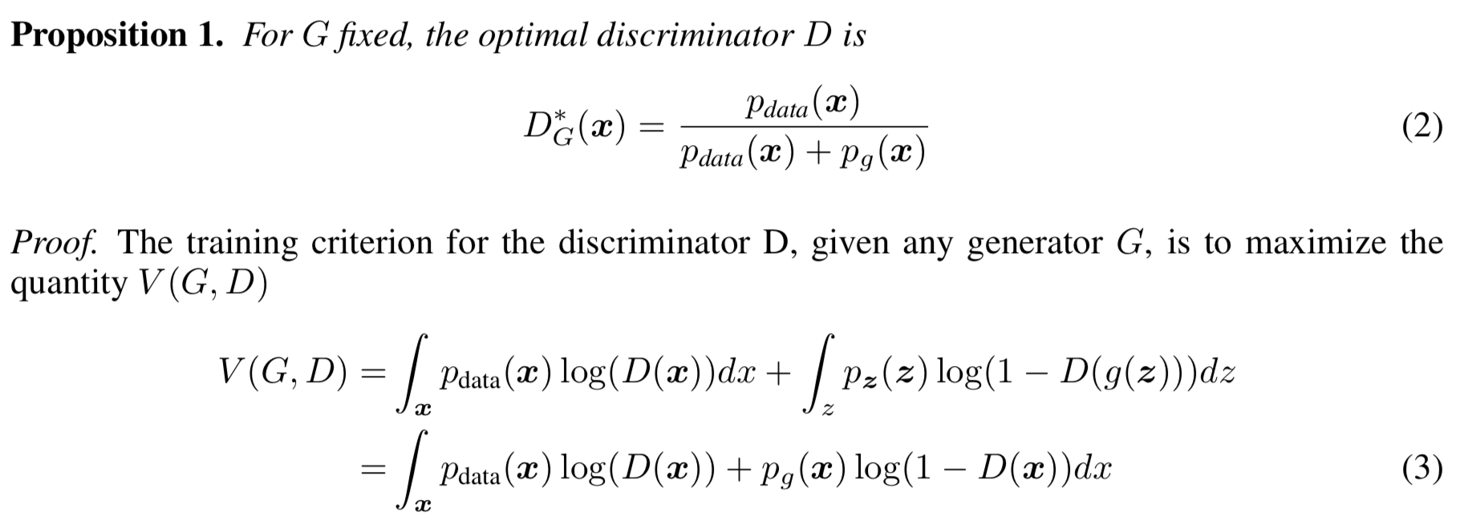

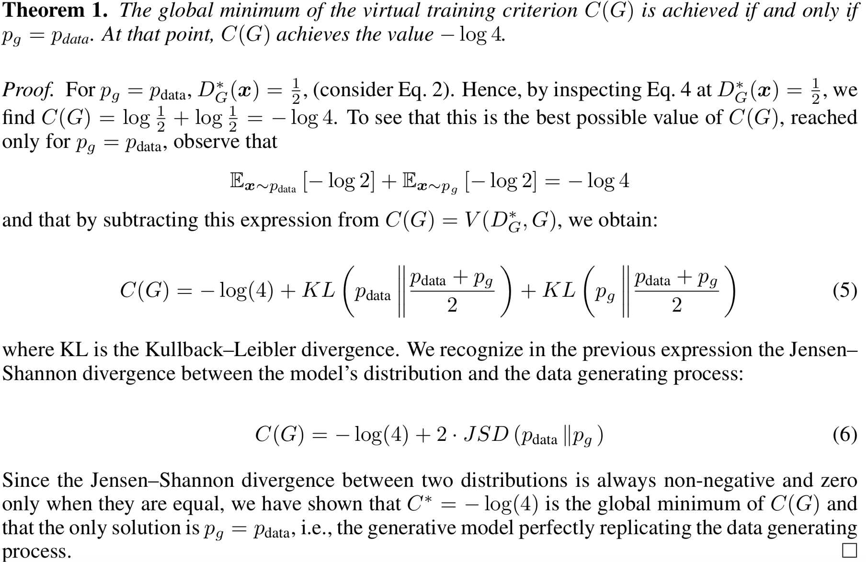

4.2 Convergence of Algorithm 1

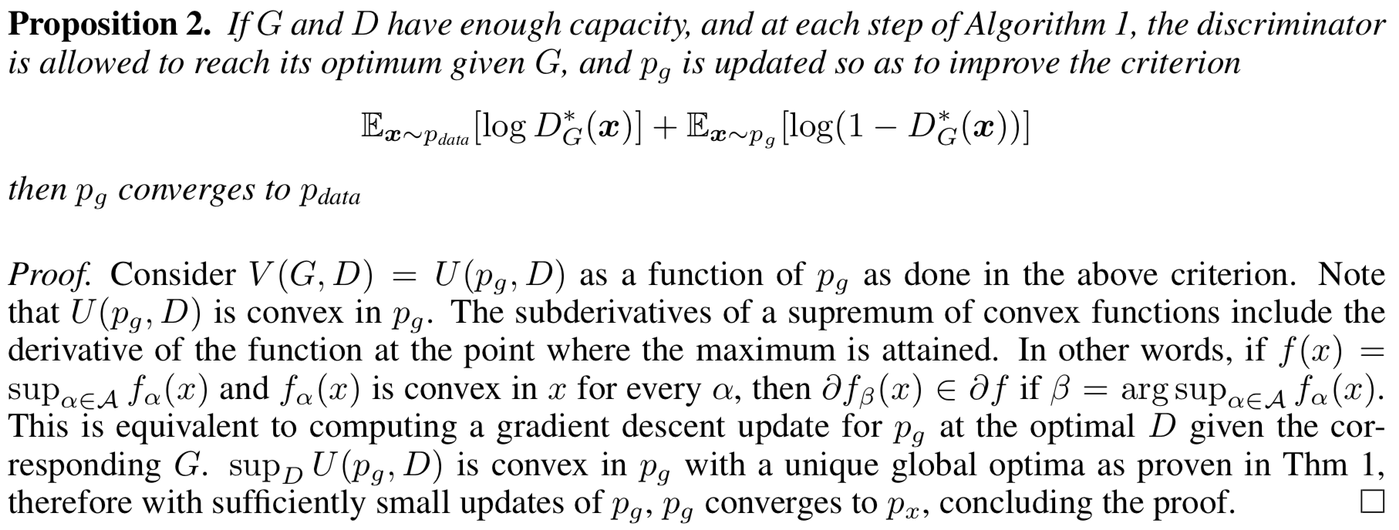

5 Experiments

6 Advantages and disadvantages

7 Conclusions and future work

1. A *conditional generative* model p(x | c) can be obtained by adding c as input to both G and D
2. *Learned approximate inference* can be performed by training an auxiliary network to predict z given x. This is similar to the inference net trained by the wake-sleep algorithm but with the advantage that the inference net may be trained for a fixed generator net after the generator

net has finished training.

3. One can approximately model all conditionals p(xS | x̸S) where S is a subset of the indices of x by training a family of conditional models that share parameters. Essentially, one can use adversarial nets to implement a stochastic extension of the deterministic MP-DBM .

4. *Semi-supervised learning*: features from the discriminator or inference net could improve performance of classifiers when limited labeled data is available.

5. *Efficiency improvements:* training could be accelerated greatly by divising better methods for coordinating G and D or determining better distributions to sample z from during training.